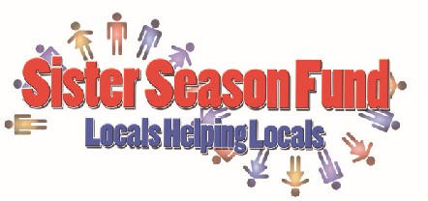

A Florida Not For Profit Corporation 501 (c)(3)
Conch Republic Days Bed Race 2023 Registration Form
Mail or email Registration and entry fees to: Julie Hanson, Sister Season Fund, Inc.
P.O. Box 4535, 422 Fleming t. Key West, FL 33040
info@sisterseason.com (305)305-9828

Team Name Sponsor Captain Name
Mailing Address
Contact Phone # Email
Release Waiver of Liability
I hereby release the sponsors, Sister Season Fund, Inc., City of Key West, Conch Republic Days and any other person officially connected with this competition from all liability for any injury and damages whatsoever arising from my participation in the event. I hereby give my permission for Sister Season Fund, Inc. to use my picture and/or videotape image and/or name in any publicity deemed necessary for the promotion of the event with no compensation. I hereby acknowledge that I have read and understand the Bed Race Rules and Regulations and agree to abide by them.

Captain
Print Signature DOB

Member

Print Signature
DOB

Member

Print Signature
DOB

Member

Print Signature
DOB

Member

Print Signature
DOB

Member

Print
Signature
DOB

